(Approx. 997 words)

A DVI story
Author: Jim Sanders, Director, North Orange County Computer Club, CA
September 2019 issue, Orange Bytes
www.noccc.org
jsanders (at) ligasmicro.com
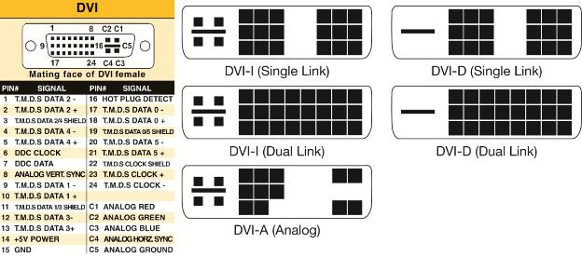

Sometimes learning experiences occur for simple reasons. This particular learning experience happened because of the way I organized my test bench. This experience revolves around the video interfaces on the computers that most of us use. You know, the connection to the monitor that puts the pretty picture on the display. In particular, the VGA port, the DVI-I port and the connectors they use. Just to refresh your memory on what those acronyms stand for:

VGA stands for "Video Graphics Array." The VGA standard was originally developed by IBM in 1987 and allowed for a display resolution of 640x480 pixels. Today, it typically supports up to 1080p. The quality of the signal begins to drop off above 1920x1080 (1080p) which will cause a drop in image quality due to the analogue nature of the signal. With a good enough cable (shorter is better) and transceiver on either end it can be used for resolutions up to and including 2048x1536, your mileage may vary.

DVI stands for (D)igital (V)ideo (I)nterface. It is a video display interface developed by the Digital Display Working Group (DDWG). The digital interface is used to connect a video source, such as a video display controller, to a display device, such as a computer monitor. It was developed with the intention of creating an industry standard for the transfer of digital video content. This interface is designed to transmit uncompressed digital video and can be configured to support multiple modes such as DVI-A (analog only), DVI-D (digital only) or DVI-I (digital and analog).The single link DVI-D can produce a near perfect 1920x1200 (WUXGA) image @ 60Hz on displays and the dual link a near perfect 2560x1600 (WQXGA) image @ 60Hz on displays.
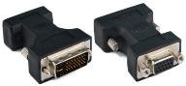
In order to reduce the clutter around the test area, I bought a very flexible, small diameter, VGA cable to hook the 1920 x 1080 monitor to whatever computer I was working on at the time. Depending on age and other factors, most end-user computers have either VGA only ports, or DVI-I only, or both. For computers that only have one of the three Analog capable DVI connectors, I have acquired the three different DVI to VGA adaptors. Newer computers may have HDMI and/or Display Port ports as well.

One of the learning experiences here was that I didn't need three DVI to VGA adaptors, just one, the DVI-A pin out adaptor. The female, Analog capable, DVI connector that is on any one computer, can be one of the three shown in the diagram. As you can see in the above chart, the DVI-A will mate with the other two pin outs. The other two pin outs have limits.

A second learning experience had to do with my long-term assumption (remember the definition of assume!) that contained within the DVI to VGA adaptor was a clever little integrated circuit that did the conversion. WRONG! Heretofore, I had not bothered to look up WHY there are different pin outs on DVI connectors. I just acquired the right cable or adaptor that worked with a given system. If it mechanically mated and electronically worked, life was good. When I was forced to research my problem, it only took a view minutes on Google to learn the facts of DVI life. Whereupon, I really felt the weight of one definition of assume! If that is confusing go here: https://www.urbandictionary.com/define.php?term=Assume

A DVI to VGA adaptor doesn't contain a clever little IC that converts the digital signal to an analog signal. That clever little IC (that contains DACs, Digital to Analog Converter) is on the Mother Board or Video Card and makes the analog signals available on pins of the DVI connector. The only adapting the DVI to VGA adaptor does is to run wires from the correct pins on the DVI connector that contain the analog video signals, to the appropriate pins on the VGA connector.

What precipitated this learning experience? I was upgrading a clients computer to a new RX 570 video card which has Display Port, HDMI and DVI-D connectors. My test monitor only has VGA and DVI-I dual link connectors. If you look at the chart, it is obvious that none of my DVI to VGA adaptors can plug into a DVI-D female connector. Not to mention, there are no analog signals in a DVI-D connector anyway! It turned out that I had 4 DVI cables of differing lengths in stock, but all of them were DVI-I dual link cables. It being late and wanting to finish the job, I figured what the hey, I will modify one cable by breaking off the four pins surrounding the blade that keep it from mating. I did that and it still would not seat in the DVI-D connector. Looking closely, I could see that the blade in a DVI-I male connector is wider than the female slot in the DVI-D connector on the RX 570 video card. A little grinding with the Dremel tool and it slid right in and worked.

A few tidbits: The digital video signals in a HDMI connector are the same as DVI-D which makes it easy to make an adaptor cable you can buy for under $10. HDMI connectors come in three sizes, standard, mini, and micro. A HDMI 2 in 1 T Adapter Connector Female To Mini HDMI Male And Micro HDMI Male Adapter is handy for connecting phones and tablets to a standard HDMI cable. There is a long list of powered adaptors that allow you to connect devices with different connector types and electronic signals to each other. Most are under $50.00. In part because there is a royalty fee on HDMI connectors, for several electrical, mechanical, and economic reasons, Display Port is becoming the preferred video port. In the future, maybe, hopefully, Display Port will be the one and only to deal with.

